# Parameters:

|  |  |  |
| --- | --- | --- |
|  | Nominal | Actual |
| C | 10-8 F | 1.045x10-8 F |
| R | 1000 Ω | 980.48 Ω |
| L | 10-3 H | 9.96x10-3 H |
| f | 104 Hz | 10000 Hz |
| t | 10-4 s | 0.0001 s |
| ωo | 62831.85 rad/s | 62831.85 rad/s |
| Vin | 1 V­­m | 1 V |

# RC Circuit:

|  |  |  |  |
| --- | --- | --- | --- |
|  | Theory (Ω) | Experimental (Ω) | % Deviation |
| Xc | -1523.013809 | -1581.45 | 3.84% |
| Z magnitude | 1811.32882 | 1896.48 | 4.70% |
| Z θ | -57.22753056 | -57.456 | 0.40% |

|  |  |  |  |  |  |  |  |  |  |
| --- | --- | --- | --- | --- | --- | --- | --- | --- | --- |
|  | theory magnitude (Vm) | theory θ (degrees) | exp mag (Vm) | exp delay (s) | exp θ (degrees) | % dev magnitude | % dev θ | theory complex rectangular | experimental complex rectangular |
| VC | 0.840826797 | -32.77246944 | 0.834 | -9.300x10-6 | -33.480 | 0.81% | 2.16% | 0.706989702019343-j0.455143123926907 | 0.695621413633384-j0.460072656104111 |
| VR | 0.541304256 | 57.22753056 | 0.517 | 1.596x10-5 | 57.456 | 4.49% | 0.40% | 0.293010297980657+j0.455143123926907 | 0.278118665168127+j0.435819926213911 |

Supplemental data:

Experimental circuit current: 0.000283655622927675+j0.000444496497851982 A

# A picture containing electronics Description automatically generatedRL Circuit:

|  |  |  |  |
| --- | --- | --- | --- |
|  | Theory (Ω) | Experimental (Ω) | % Deviation |
| XL | 625.8052566 | 623.7106 | 0.33% |
| Z mag | 1163.173783 | 1241.114 | 6.70% |
| Z theta | 32.54863159 | 31.212 | 4.11% |

|  |  |  |  |  |  |  |  |  |  |
| --- | --- | --- | --- | --- | --- | --- | --- | --- | --- |
|  | theory magnitude (Vm) | theory θ (degrees) | exp mag (Vm) | exp delay (s) | exp θ (degrees) | % dev magnitude | % dev θ | theory complex rectangular | experimental complex rectangular |
| VL | 0.53801527 | 57.45136841 | 0.503 | 1.565x10-5 | 56.340 | 6.51% | 1.93% | 0.289460430428336+j0.453511950939089 | 0.278794529804557+j0.418667660741854 |
| VR | 0.842935092 | -32.54863159 | 0.79 | -8.670x10-6 | -31.212 | 6.28% | 4.11% | 0.710539569571664-j0.453511950939089 | 0.675652039401563-j0.409382854614734 |

Supplemental data:

Experimental circuit current: 0.000689103336530641-j0.000417533100741202 A

# A picture containing text Description automatically generatedRCL Series Circuit:

|  |  |  |  |
| --- | --- | --- | --- |
|  | Theory (Ω) | Experimental (Ω) | % Deviation |
| Xc | -1523.013809 | -1509.06 | 0.92% |
| XL | 625.8052566 | 618.5189 | 1.16% |
| Z mag | 1329.031308 | 1392.727 | 4.79% |
| Z theta | -42.46071928 | -40.932 | 3.60% |

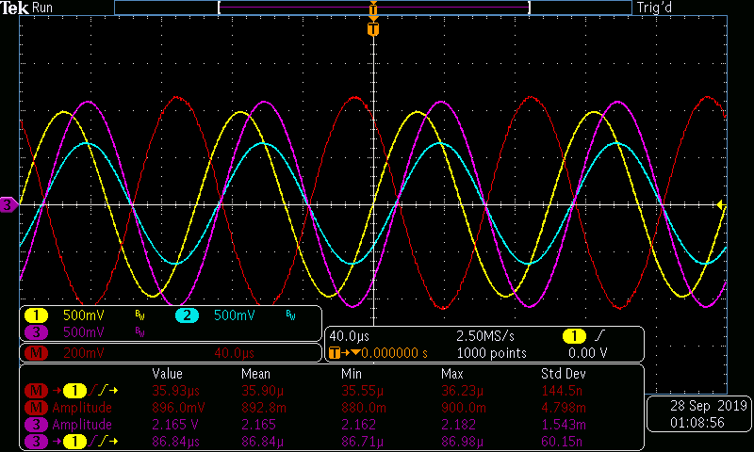

|  |  |  |  |  |  |  |  |  |  |
| --- | --- | --- | --- | --- | --- | --- | --- | --- | --- |
|  | theory magnitude (Vm) | theory θ (degrees) | exp mag (Vm) | exp delay (s) | exp θ (degrees) | % dev magnitude | % dev θ | theory complex rectangular | experimental complex rectangular |
| vc | 1.145957812 | -47.53928072 | 1.084 | -1.316E-05 | -47.376 | 5.41% | 0.34% | 0.773618457071704-j0.845419297821795 | 0.734067722575404-j0.797621826853402 |
| vl | 0.470873224 | 132.4607193 | 0.4443 | 3.590E-05 | 129.240 | 5.64% | 2.43% | -0.317879256259661+j0.347382169029931 | -0.281050922938001+j0.344111709646297 |
| VR | 0.737740333 | 42.46071928 | 0.704 | 1.137E-05 | 40.932 | 4.57% | 3.60% | 0.544260799187957+j0.498037128791864 | 0.531863323232626+j0.461234653294771 |

Supplemental data:

Theoretical circuit current: 0.000555096278545159+j0.000507952358836349 A

Experimental circuit current: 0.000542451985999333+j0.000470417196979817 A

# Questions:

1. What is the phase relationship between R, L, and C components in a series AC circuit?

Per the phasor diagram (last page) in a sinusoidal steady-state series RLC circuit, the resistor voltage phasor is orthogonal to the inductor and capacitor voltage phasors. The inductor and capacitor voltage phasors oppose each other by 180 degrees. The sum of the component voltage phasors is equal to the voltage source phasor V­in.

1. Based on measurements, does Kirchhoff’s Voltage Law apply to the three tested circuits? (show work)

$$\text{Circuit 6.1:}{ -V}_{in}+V_{c}+V_{r}=0 \\ V_{c}+V_{r}=V_{in} \\ 0.834∠-33.48° + 0.517∠-57.46°= 1 \\ 0.6956 - j0.4601 + 0.2781 + j0.4358 ≈1 \\ 0.9737 - j0.0243 ≈1$$

$$\text{Circuit 6.2:}{ -V}_{in}+V_{L}+V_{R}=0 \\ V_{L}+V_{R}=V_{in} \\ 0.2788 + j0.4187 + 0.6757 - j0.4094 ≈1 \\ 0.9545 + j0.0093 ≈1$$

$$\text{Circuit 6.3}\text{:} -V_{in}+V_{R}+V_{C}+V_{L}=0 \\ V_{R}+V_{C}+V_{L}=V_{in} \\ 0.7341 - j0.7976 - 0.2811 + j0.3441 + 0.5319 + j0.4612 ≈1 \\ 0.9849 + j0.0077 ≈1$$

Differences in the sum of component voltages compared to the source voltage is likely due to one of the following reasons: parasitic capacitance in the probes, test equipment, breadboard, resistor, and wires. Additionally, most components have a tolerance between 5-10% of the nominal value that is frequency dependent.

1. In general, how would the phasor diagram of Circuit 6.1 change if the frequency was raised?

As the frequency increases, the phase angle of the resistor voltage would approach the phase angle of the source, while the capacitor voltage phase angle approaches -90 degrees (or 90 degrees lagging) from the source voltage phasor.

1. In general, how would the phasor diagram of Circuit 6.2 change if the frequency was lowered?

As the frequency decreases, the phase angle of the resistor voltage would approach the phase angle of the source, while the inductor voltage phase angle approaches 90 degrees (or 90 degrees leading) relative to the source voltage phasor.

